**Name of the programme**: Career Counselling Fair

**Date of the programme**: 28.11.2018

**Organized by**: Career Counselling Cell, Chakdaha College

**Resource persons:** Experts from organization/Institution from the field of management, hospitality management, Coaching in computer related course, competitive examination, animation, tax consultant etc.

**Objective of the programme:** The objective of the career fair is to create opportunities for students to explore various career options, learn about different companies and industries, and potentially secure employment or internships.

**Outcomes of the programme:**

1. Students gained insights into different companies’ cultures, values, and work environments, helping them make informed decisions about their career choices.
2. Students got knowledge on various competitive examinations to get Govt. Job.
3. Students got to know, internship opportunities that provide valuable work experience and skill development.

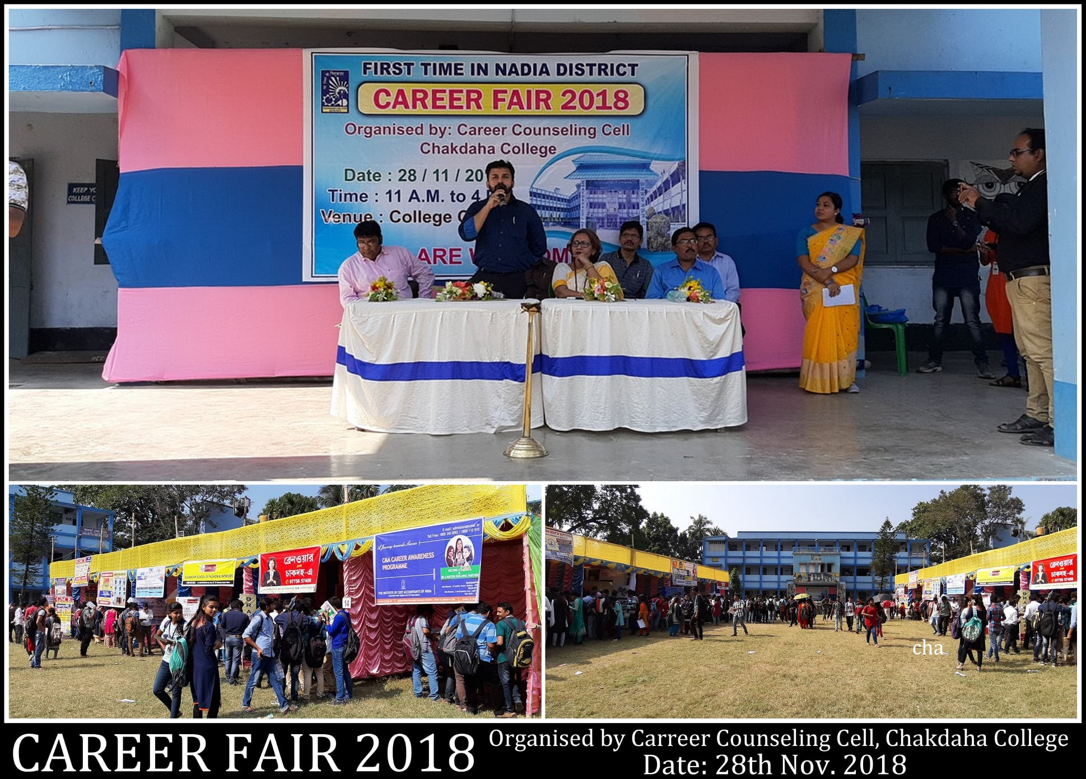

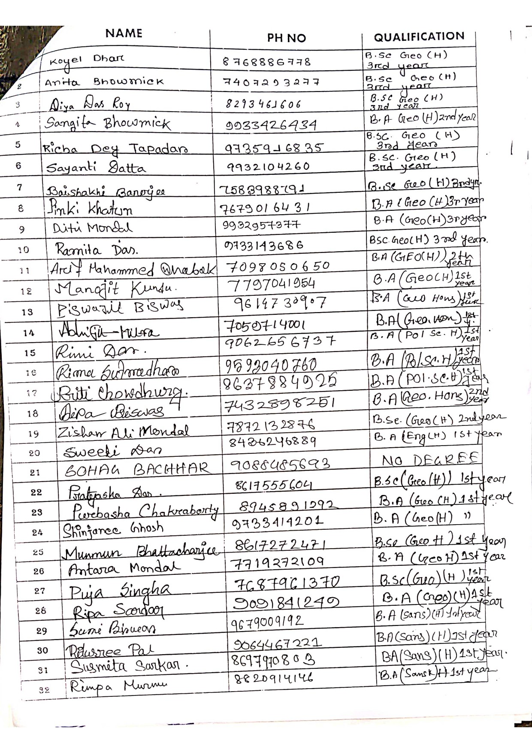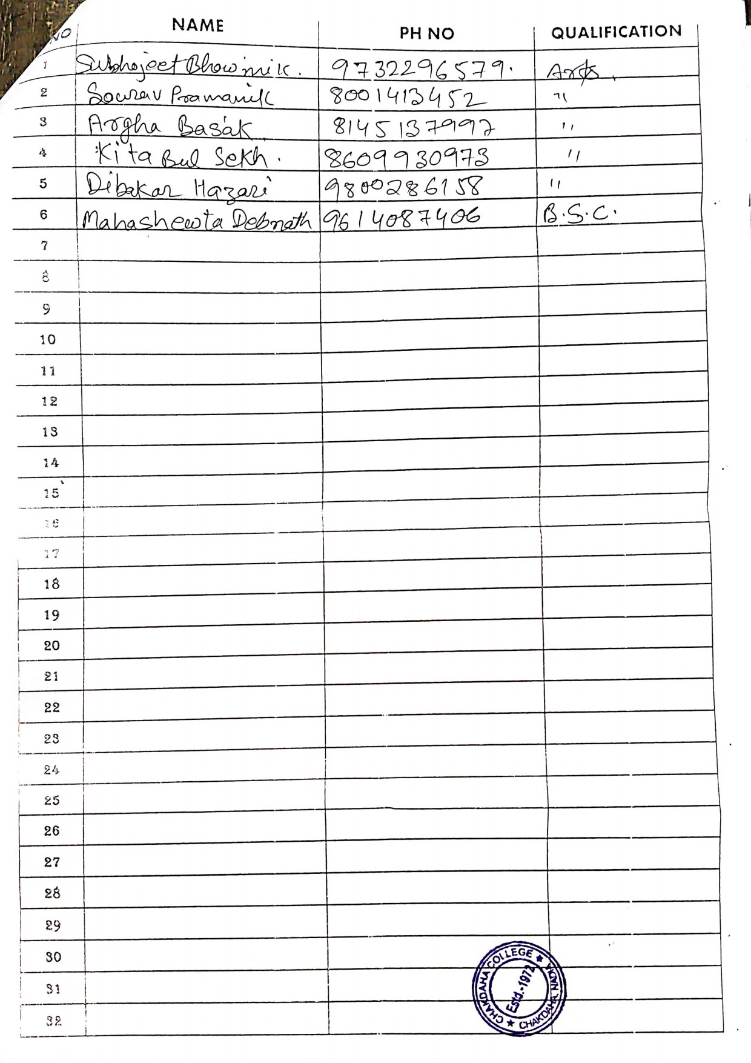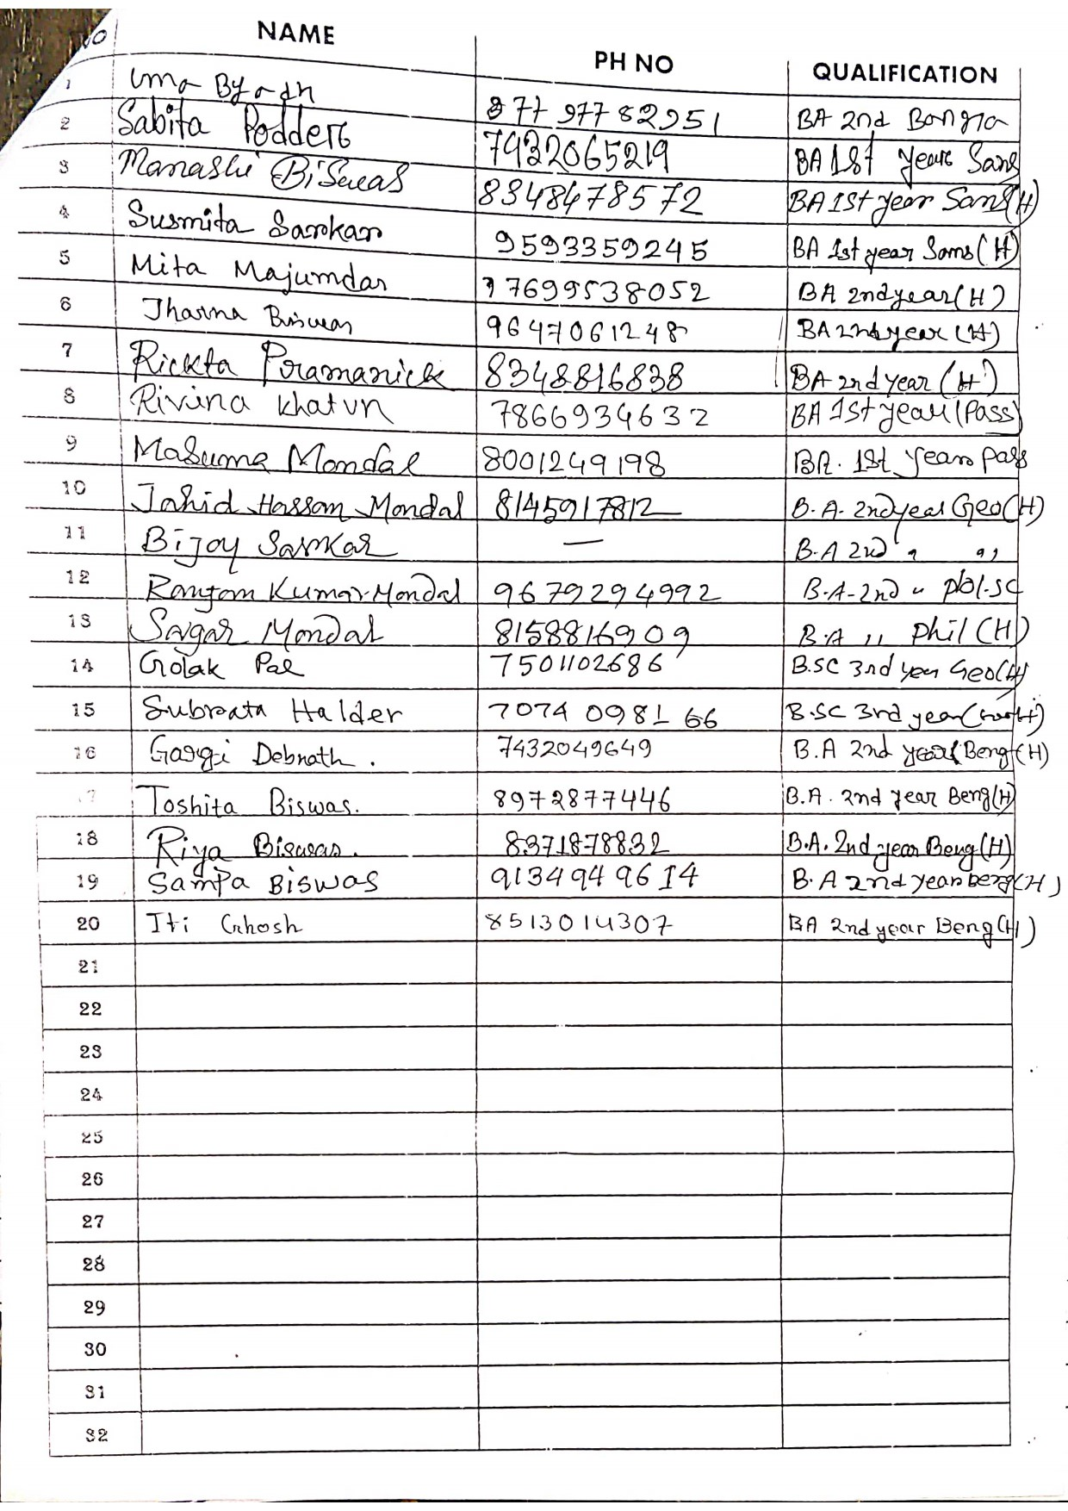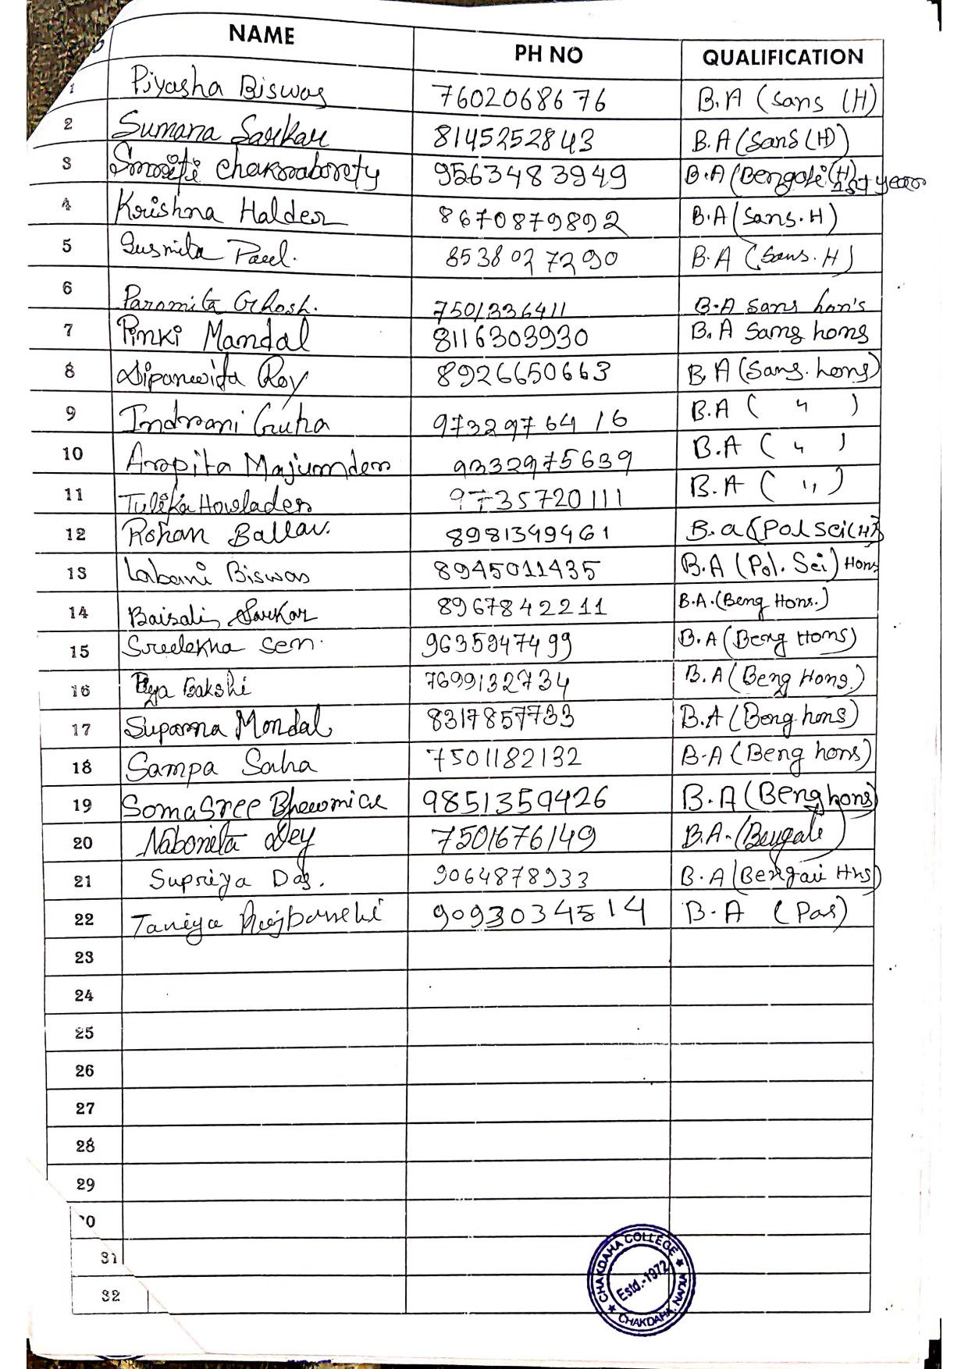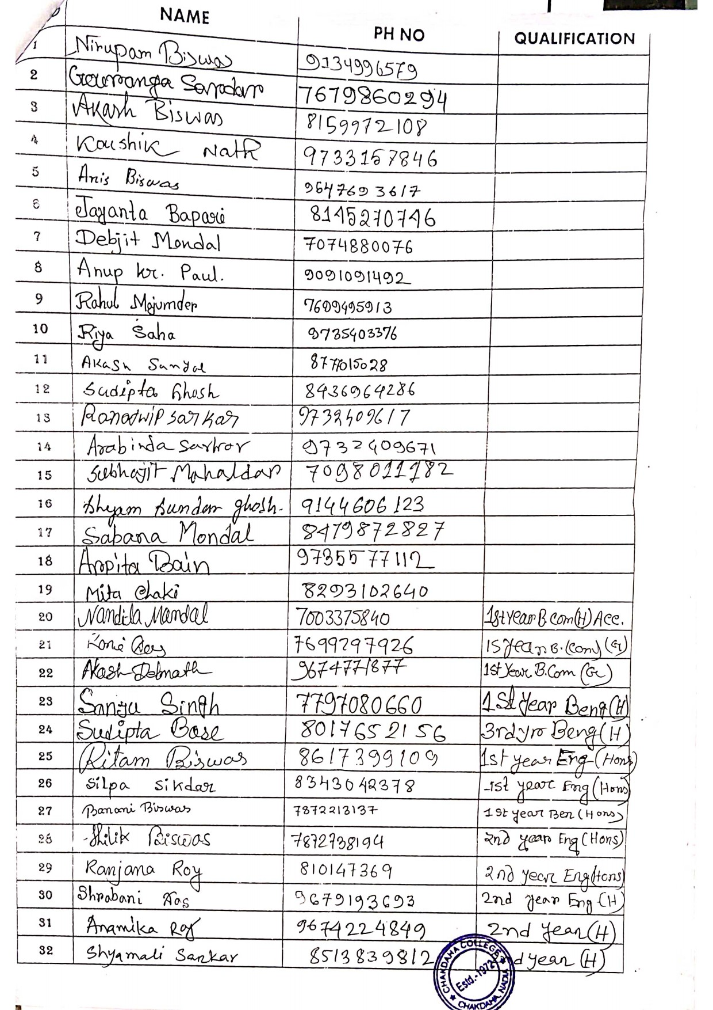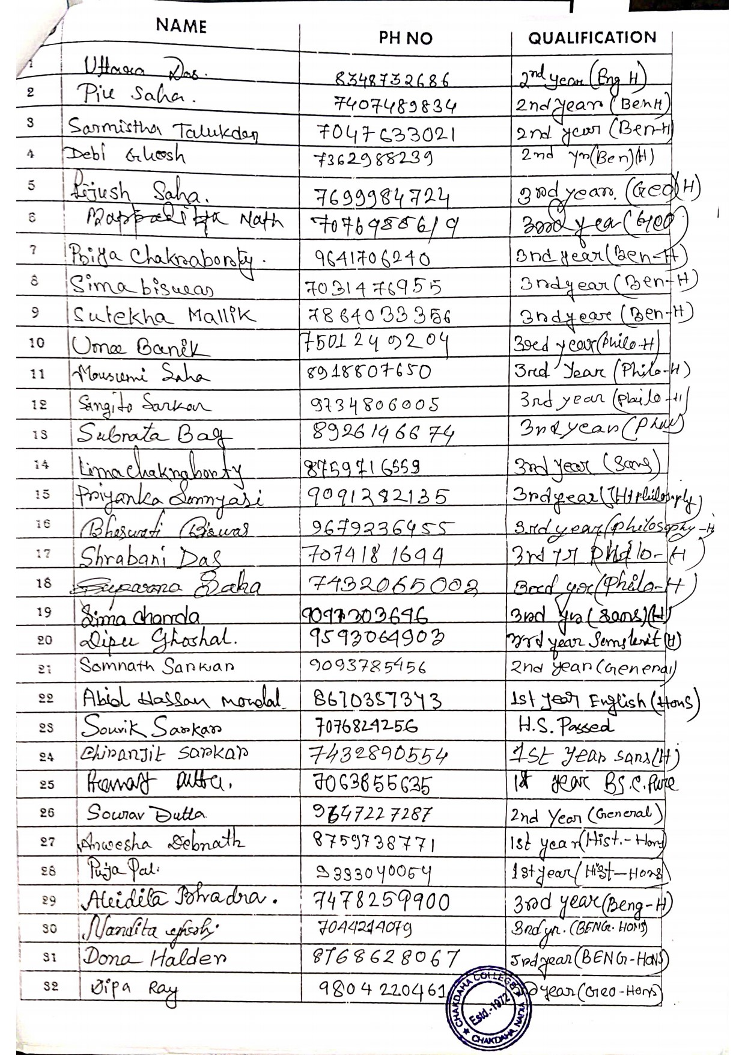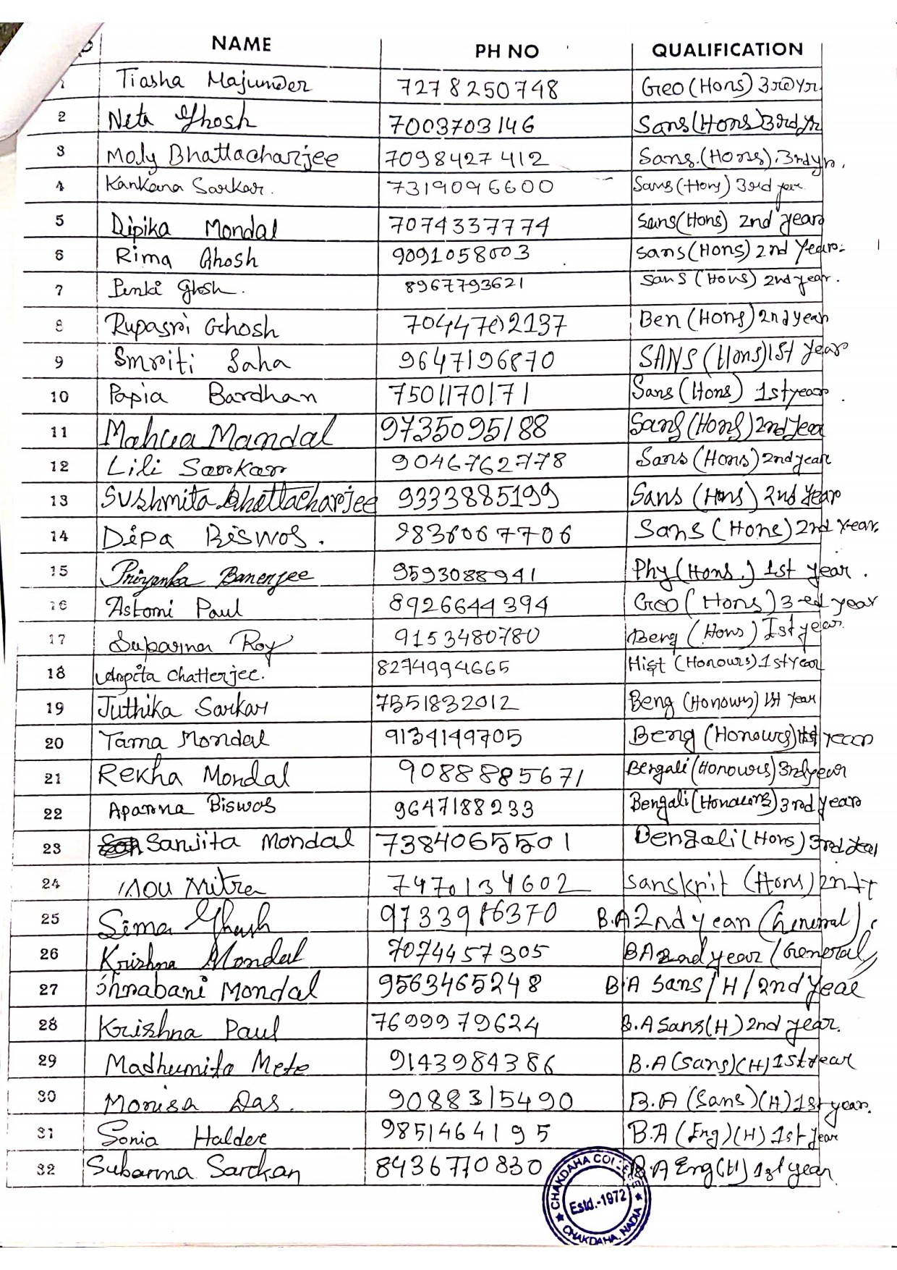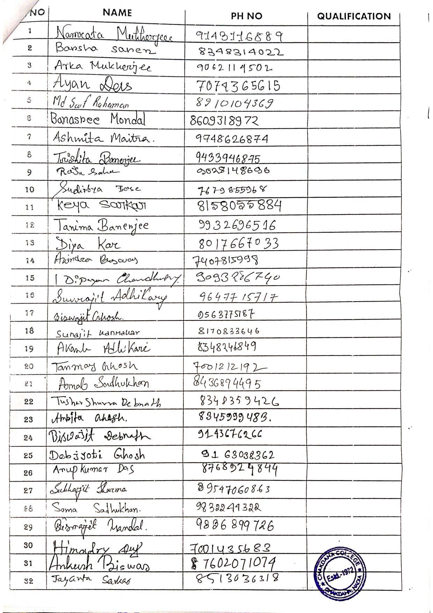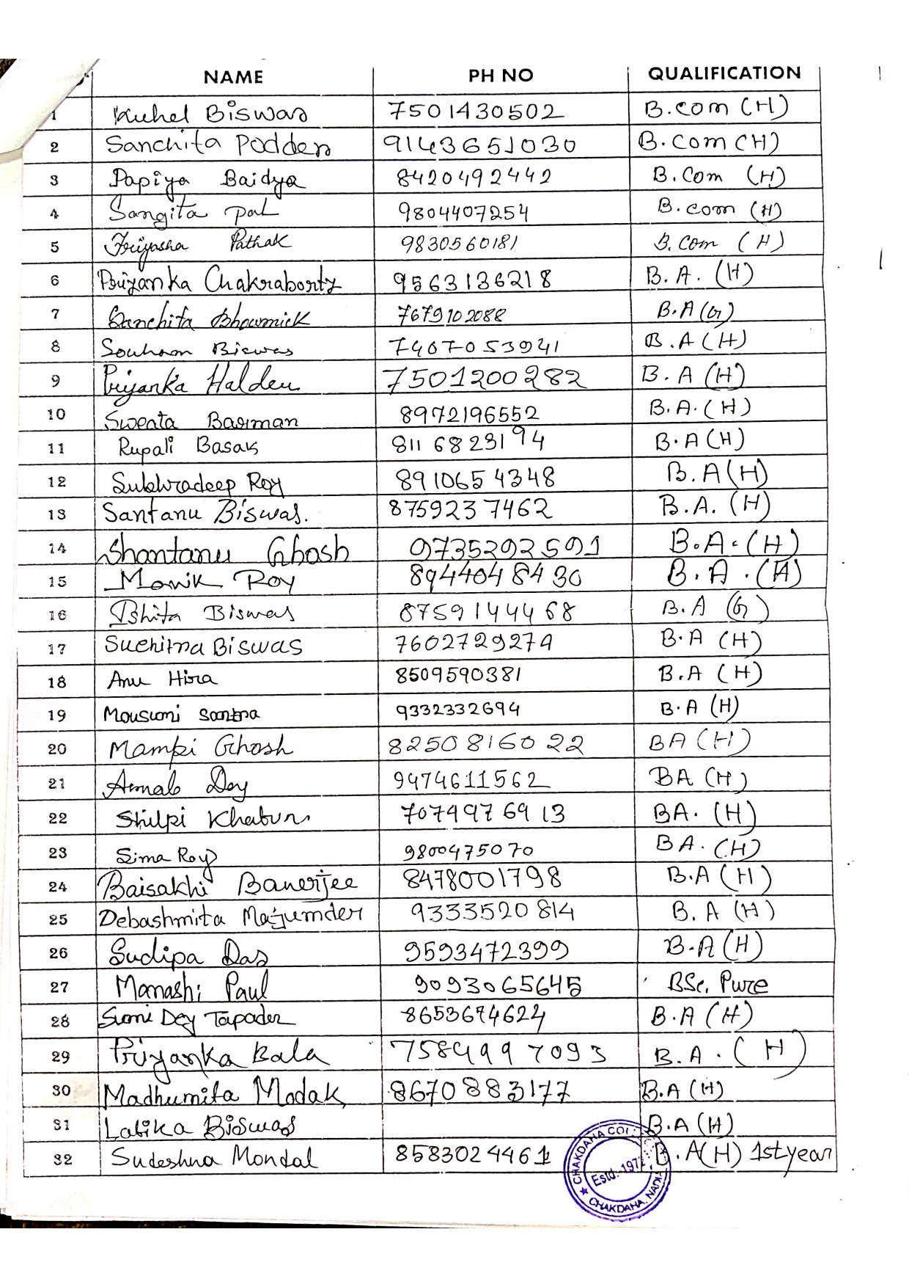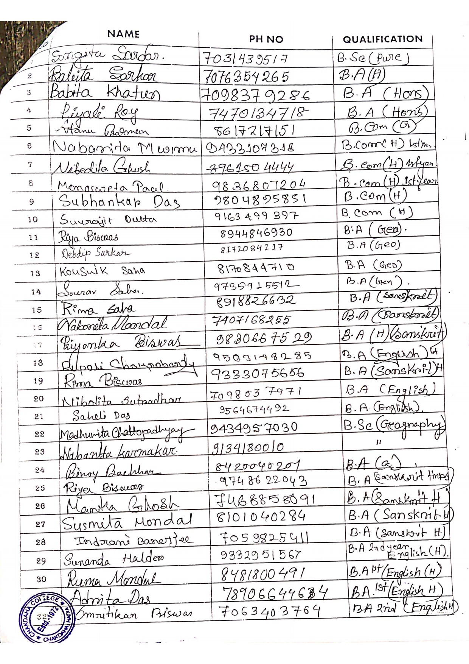

List of Students Participated